<<20130213>> Archived distributions can be retrieved at; <http://tinyurl.com/azg3eyl>. This archive includes a html version of this list distribution and its MS/WORD version with its filename as “year-month-date.doc.” You can also access all of its attachments, if any.
Prof. Edwin Scott Asemota, MD., DTMPH
Prof. of Medicine and CEO, Help Point International Foundation
Phone in Germany: ( + 49 ) 1578-7144-074
Phone in Nigeria ( +234) 81-6776-5921
Scotta-Help-point@t-online.de
References:
(a) The Global Early Warning System (GEWS) with The Global University System (GUS): Their Use Within ECOWAS Countries; A Priority Agenda Item of the First GEWS/GUS Planning Workshop at School of International and Public Affairs (SIPA), Columbia University, and The Stevens Institute of Technology (August 2, 2012)
<http://tinyurl.com/bmo9ljj>
(b) Thank-you-note to Tak Utsumi from Prof. Edwin Scott Asemota, dated February 4, 2013
<http://tinyurl.com/adrfqn9>
Dear Edwin:
(1) Many thanks for your msg (ATTACHMENT I below).
I greatly appreciate your enthusiastic interest in our GEWS/GUS projects.
(2) Our project schedules are;
(a) “Global Lecture Hall (GLH)” videoconferencing on April 18th,
(b) Planning workshop at the GLORIAD office at the University of Tennessee in Knoxville (UTK),
(c) Workshop with demonstration at the SIPA of Columbia University in NYC — see Reference (a) above.
(3) Sorry to say that the webinar of the April 18th event can accept only 6 feeds (including Stevens Institute of Technology), so that I have to drop one of them listed in the last page of the Reference (a) above — and, thus, it cannot accommodate you. However, the webinar can provide the views of the auditorium and the images of the selected ECOWAS colleagues, and then accept questions from general audiences. Therefore, you can come in as one of them.
We will soon announce how to access the webinar in our list.
You may attend our workshop at Columbia University — hopefully to be held in late of this coming fall.
(4) My replies to your msg are in red marked.
(5) Many thanks also for your msg with kind words (ATTACHMENT II below).
Keep in touch. Let’s work together.
Best, Tak

ATTACHMENT I
From: "Scotta-Help-point@t-online.de" <Scotta-Help-point@t-online.de>
Subject: Re: "Global Lecture Hall (GLH)" videoconferencing on April 18th
Date: January 29, 2013 7:01:46 AM EST
To: "Tak Utsumi" <takutsumi0@gmail.com>
Cc: robert.harari@stevens.edu
Reply-To: "Scotta-Help-point@t-online.de" <Scotta-Help-point@t-online.de>
Dear Robert and Tak,
I have received your preliminary plans for the April 18, 2013 video-conference of the Global University System (GUS) - Their Use within ECOWAS Countries - I will be glad to participate in this event
You may be able to participate in it through the webinar — see above.
because I am working on deploying GUS broadband network for Telemedicine to be used for care and training of Doctors and other health care providers in Nigeria.
Yes, this is the direction our GUS is aiming for, and is one of our reasons why we worked on the matchmaking between the “Africa Coast to Europe (ACE)” (of Baharicom Development Company) ultra high-speed optical fiber submarine cable along the west coast of Africa with GLORIAD. Victor Lawrence, Chairman of Baharicom recently said that it will be landing in Nigeria in this coming July — I don’t know if and how it will be extended to Abuja.
The Federal Ministry of Health is interested in the program with a request that this be delivered on a Public Private Partnership basis.
To be able to provide the Government and viewers concrete pictures of how GUS Broadband access will revolutionize care in the region, I need your support by way of answers to the following questions.
Not only we would be happy to arrange the discount rate of the ACE/GLORIAD from the Baharicom Philanthropic Foundation for Humaniterian/Education uses, we also plan to help our African colleagues (including Nigeria) to get the Japanese ODA funds — the last page of the Reference says that USD$ 3.5 billion for education and USD$ 5 billion for healthcare are available for developing countries.
These will be pin-pointed to the Federal Minister of Health in my presentation already scheduled.
In phase 1 of the Telemedicine program, about 20 Telepoints are planned to be set up. From here, information on care and training will be co-shared with pre-select centers in Europe and in the USA.
Those Telepoints may be linked with Wibro (*) broadband wireless Internet at 75 Mbps — I think that Nigeria already has its use as Rwanda. (*) South Korean technology.
Questions:
1. Could GUT prepare and provide check-list of current best practice hardwares needed to set-up such Telepoints ?
I have one Sony Professional Tele-conferencing model presented to me as a demonstration unit.
One unit costs 12.000 US$ ( Twelve thousand US Dollars )
India and China produce much cheaper models but these have relative poor resolution properties compared with Sony's.
Most important first step is to have a strong champion in each country — with whom we can work about those things cooperatively.
2. Judging from programs already done, what is the approximate cost estimate for the essential hardware for a Telepoint including all necessary accesories, using products from best practice providers ?
Once we have such champion and get the aforementioned Japanese ODA, the Japan International Cooperation Agency (JICA) can provide those figures.
3. The current best commercial price to access broadband internet service at 32.000 kbts/sec in Germany
is 23,23 Euro = 31.22 US$, what will services provided through GUS cost the Government ?
See above.
Please bear in mind that this is supposed to be subsidized as part of Africa Care Development plan to improve life and meet United Nations Development Goals (MDG) by 2013.
4. The Government is interested in a Public Private Partnership plan.
What role will GUS play as the potential technical partner in such plan ?
As mentioned before elsewhere, we have already helping them to get broadband Internet through GLORIAD.
What exactly does a counter-part at the point of access for a country do ?
We will formulate those items at our workshops at the GLORIAD at the UTK and SIPA at Columbia University as mentioned before.
What stakes does such counter-part bring in and get ?
The details will be formulated at those workshops.
5. Could GUS indeed prepare a draft business plan for the proposed Telemedicine action ?
Such plan may be part of their 5 year project proposal which is to be endorsed by their Ministry of Healthcare, which will be sent to their Ministry of Foreign Affairs, which will then be submitted to the Japan Embassy in their country for the aforementioned Japanese ODA.
6. Is GUS Broadband accessible in Liberia ?
The ultra high speed (5 tera bps) broadband Internet of ACE/GLORIAD has already landed in Liberia. Next is if and how to extend it to their universities, etc.
Among ECOWAS countries, Nigeria will be landed in the coming July and Benin by the end of this year.
An Ecowas region state , whose President, Ellen Johnson Sirleaf, Chairperson of ALMA( African Leaders Malaria Alliance ) is participating in our program " Going now from Malaria Control to Malaria Total Elimination" co-driven from University Centers in Germany and in the USA.
Telepoints are expected to be set up African wide for this program. To share training and patients awareness /sensitization on the up-coming Malaria Vaccine, one of the tools we are using.
Please take your time to kindly show me a draft an overall business plan including the modus vivendi, an ( Implementation operational procedure ) which you believe will propel my presentation to interested Governments and parties in the region.
As mentioned elsewhere, we plan to prepare such document with our counterparts in various ECOWAS countries in the series of workshops, and then submit to the Japan Embassy in their countries for the Japan ODA as mentioned above.
I am planning that the Minister of health and if possible Liberia President and Chairperson, ALMA, or their accredited delegates share in the April 18 Conferencing.
Regards,
Prof. Edwin Scott Asemota, MD., DTMPH
Prof. of Medicine and CEO, Help Point International Foundation
Phone in Germany: ( + 49 ) 1578-7144-074
Phone in Nigeria ( +234) 81-6776-5921
Scotta-Help-point@t-online.de

ATTACHMENT II
From: "Scotta-Help-point@t-online.de" <Scotta-Help-point@t-online.de>
Subject: Re: Introducing Iraqi and Nigerian friends
Date: February 4, 2013 11:47:36 AM EST
To: "Tak Utsumi" <takutsumi0@gmail.com>
Reply-To: "Scotta-Help-point@t-online.de" <Scotta-Help-point@t-online.de>
Hi Tak,
In attachment, please find my thank you letter for the mail you sent me yesterday.
I will be sending more throughts as they evolve here.
Thanks indeed and stay in touch.
Edwin
++++++++++++++++++++++++++++++++++++++++++++++++++++++++++++++++++++++++
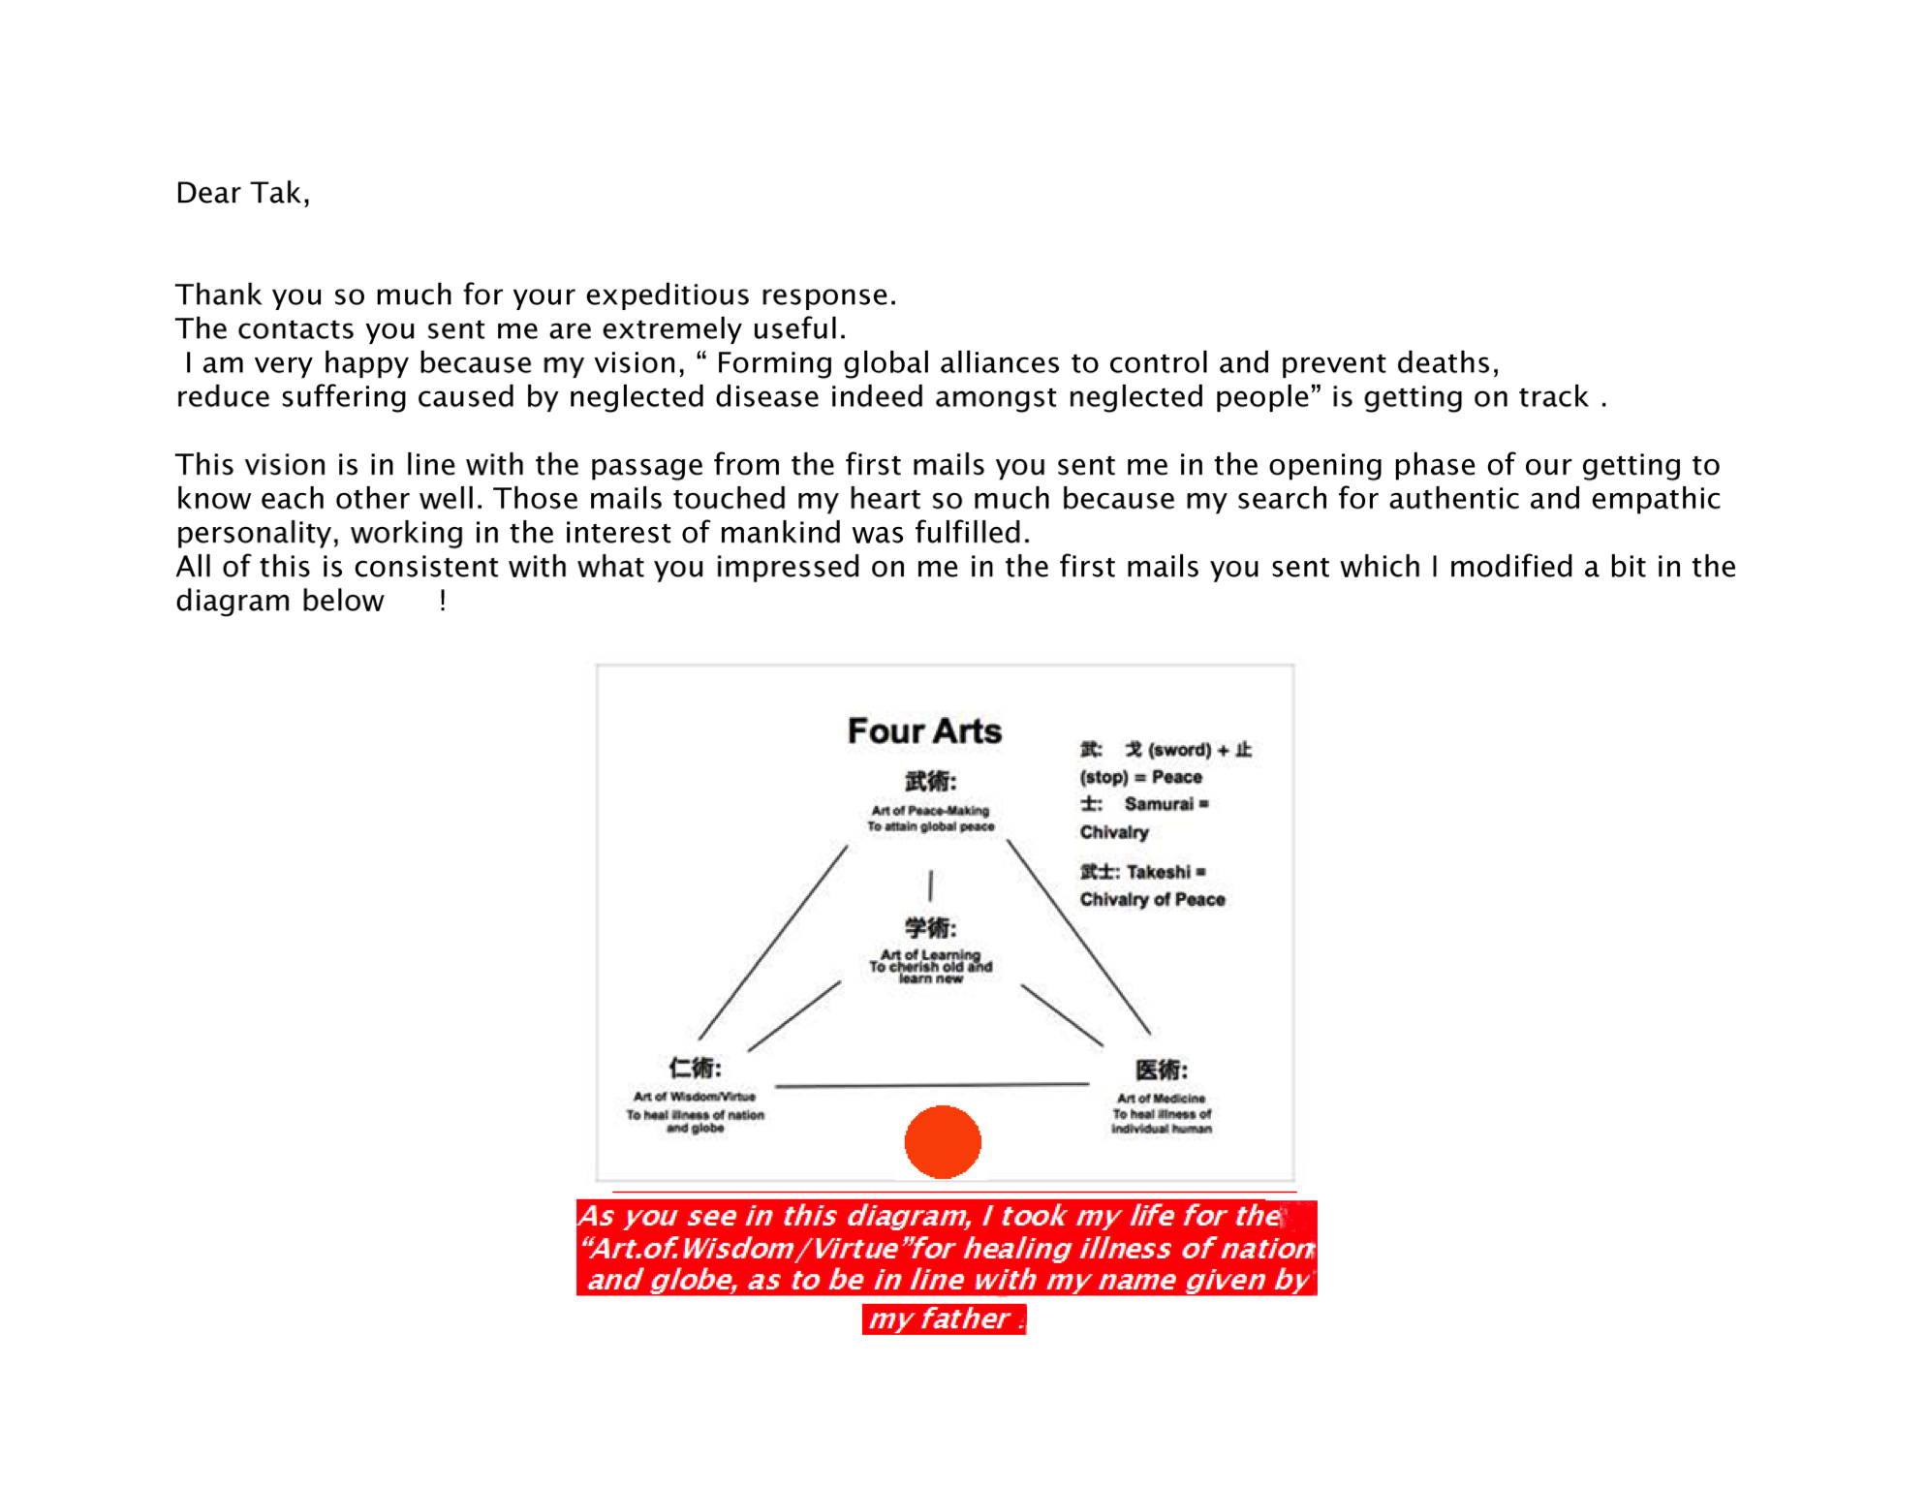
See more in <http://tinyurl.com/adrfqn9>

*******************************************************************************
Takeshi Utsumi, Ph.D., P.E., Chairman
GLObal Systems Analysis and Simulation Association in the U.S.A. (GLOSAS/USA)
Laureate of Lord Perry Award for Excellence in Distance Education
Founder and V.P. for Technology and Coordination of Global University System (GUS)
43-23 Colden Street, #9L, Flushing, NY 11355-5913, U.S.A.
Tel: 718-939-0928; Cel: 646-589-1730; Skype: utsumi
Email: takutsumi0@gmail.com, Web: http://www.friends-partners.org/GLOSAS/
U.S./IRS Employer ID: 11-2999676 <http://tinyurl.com/534gxc>
New York State Tax Exempt ID: 217837 <http://tinyurl.com/47wqbo>
Google Profiles <https://profiles.google.com/takutsumi0/about>
Facebook <http://www.facebook.com/GlobalEarlyWarningSystemsgews>
List Distribution <http://tinyurl.com/2fzx23e>
*******************************************************************************

